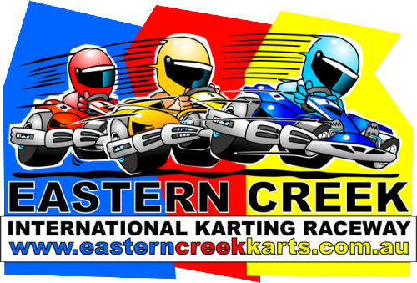
TOYOTA 86 RACING SERIES
with
EASTERN CREEK KARTS
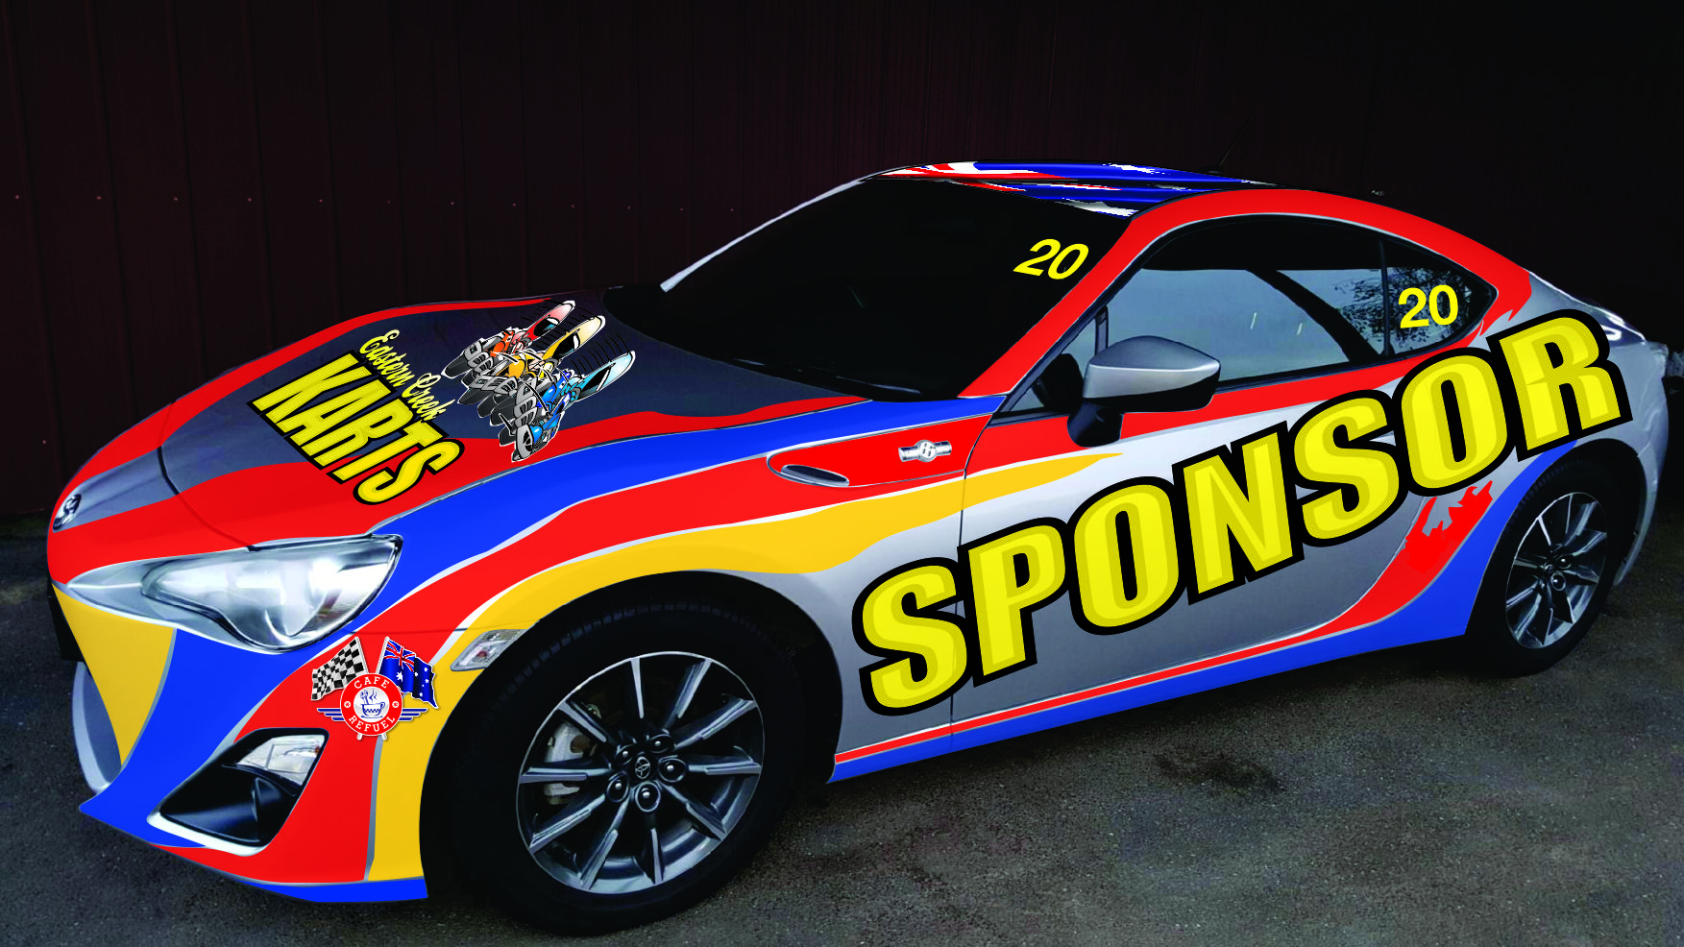

IGNITE YOUR IMAGINATION

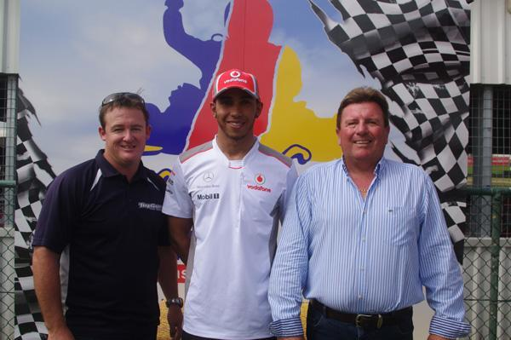
Sydney’s premier corporate action sports venue, Eastern Creek Karts is offering an exclusive sponsorship opportunity that combines a high profile, national advertising and promotion program with market leading corporate entertainment.

Eastern Creek Karts is entering the exciting new Toyota 86 Racing Series. Fully backed by Toyota Australia, the Toyota 86 Racing Series will feature on five of the leading V8 Supercars events, including the Supercheap Auto Bathurst 1000.

Nearly 500,000 spectators will be in attendance across the five events.The television coverage will attract 8 million viewers coupled with a social media reach in excess of 1.5 million people.

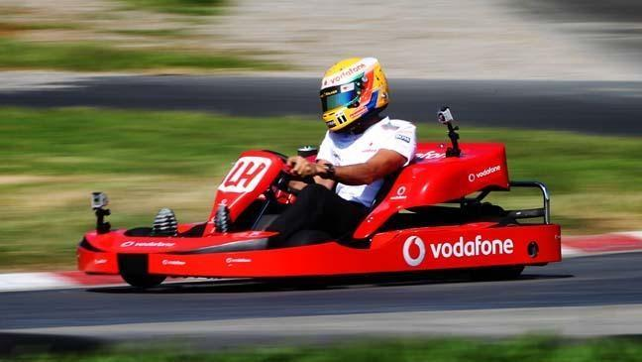
The Eastern Creek Karts (ECK) team, led by Garry Holt, is the most successful team in the ”direct-from-showroom-floor” Production Car style of racing in Australian motorsport over the last 10 years. In that decade, the ECK team has secured four Australian Championships, two outright wins in the Bathurst 12 Hour and finished no lower than second place in any Championship contested.

Team owner/driver Garry Holt is one of Australia’s most versatile all round sportsmen - he holds many national and international sporting records and has represented Australia in sports as diverse as Snow Skiing, Yachting and Game Fishing.

Each sponsorship package on offer also delivers direct access to an enviable corporate database through Eastern Creek Karts - numbering over 100,000 and includes some of the biggest corporate names in Australia. The packages are reinforced by signage for your brand at the Western Sydney - which attracts over 30,000 corporate guests each year - as well as 40,000-plus “arrive and drive” guests annually.

This is a rare opportunity to intrinsically link your product marketing activities with this exciting new nationally televised Toyota 86 race series and one of Western Sydney’s premier tourist and corporate “bonding” destinations.

MARKETING OPPORTUNITIES FOR YOUR BRAND

The program allows above-the-line marketing opportunities - such as:
- signage on car
- signage at Eastern Creek Karts
- Television and Media Exposure;
To be supported by below the line touchpoints:
- Event, team, Series & Toyota Australia social media
- Collateral handouts and activation - brochures/posters at track (at cost)
- Representatives on site (at cost)
- Corporate Hospitality (at cost)
- Electronic mailers (design at cost)

Overall, it delivers a program that is cost effective, on brand and will bring the brand to life in the most hotly anticipated racing Series to hit Australia in some years.

The ‘every session live’ nature of the Fox Sports Toyota 86 Racing Series coverage will position Your Brand in front of 8 million fans on TV and nearly 500,000 at track.

Each round of the Toyota 86 Racing Series ensures guaranteed 40 minutes of live television coverage per day through each event (NB: May alter at some events):
- 2 x 20 minute Practice Sessions (Friday)
- 1 x 20 minute Qualifying Session (Saturday)
- 3 x 20 minute Races (1 x Saturday; 2 x Sunday)

ABOUT THE TOYOTA 86 RACING SERIES
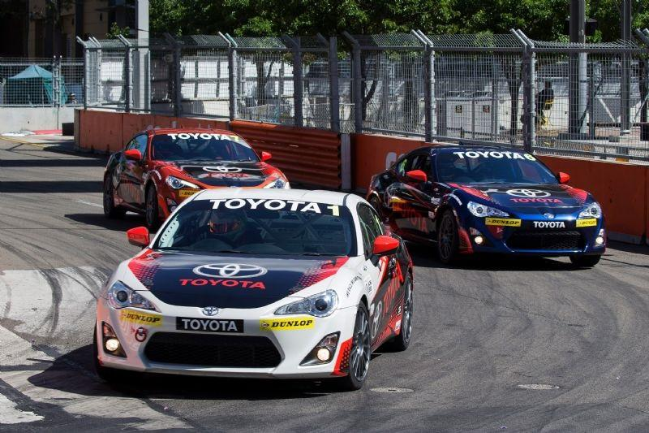

Toyota Australia is investing in the Toyota 86 Racing Series as a key marketing platform over the next three years. The aim is to drive excitement and desirability for the Toyota brand and the 86 model among motorsport fans. Toyota is investing any funds raised back into the Series to ensure a strong and viable racing platform that will ignite the imagination of race teams and racing fans.

- Australia’s newest single make motor racing Series
- Full support from Toyota Australia
- Utilising the dynamic Toyota Sportscar - the Toyota 86
- Program supports V8 Supercars at 6 major events - including 3 in NSW
- Racing includes the Sandown 500, Bathurst 1000 and Sydney 500
- LIVE TV coverage of every session on Fox Sports
- Same Day and Delayed coverage on Network TEN
- Social media reach through V8 Supercars, Toyota Australia and media outlets (over 1.5 million followers)
- Established racers will take on emerging young drivers and Professional ‘WildCard’ drivers - who will bring further interest from fans and media to the Series
EVENTS

The Toyota 86 Racing Series competes in key markets at the biggest motorsport events in Australia.
The Calendar for 2016 is as follows - with key television and attendance metrics from 2015 following:

EVENT LOCATION | DATES
Winton SuperSprint - Victoria | May 20-22
Sydney Motorsport Park SuperSprint - NSW | August 26-28
Wilson Security Sandown 500 - Vic | September 16-18
Supercheap Auto Bathurst 1000 - NSW | October 6-9
Coates Hire Sydney 500 | December 2-4

2015 KEY DATA FROM EACH EVENT
*Data supplied by V8 Supercars, Cumulative 3 Day (4 days re: Bathurst) Average Television Data supplied by V8 Supercars through OzTam. Attendance figures not supplied by Winton or SMP.

EVENT | TELEVISION AUDIENCE | AT TRACK ATTENDANCE
Winton | 726,000 | Approx 40,000
Sydney Motorsport Park | 839,000 | Approx 45,000
Sandown 500 | 999,833 | 61,088
Bathurst 1000 | 3,890,667 | 201,416
Sydney 500 | 1,492,833 | 129,232
TOTALS | 7,948,333 | 476,736
AVERAGE | 1,589,667 | 95,347

ABOUT THE TEAM
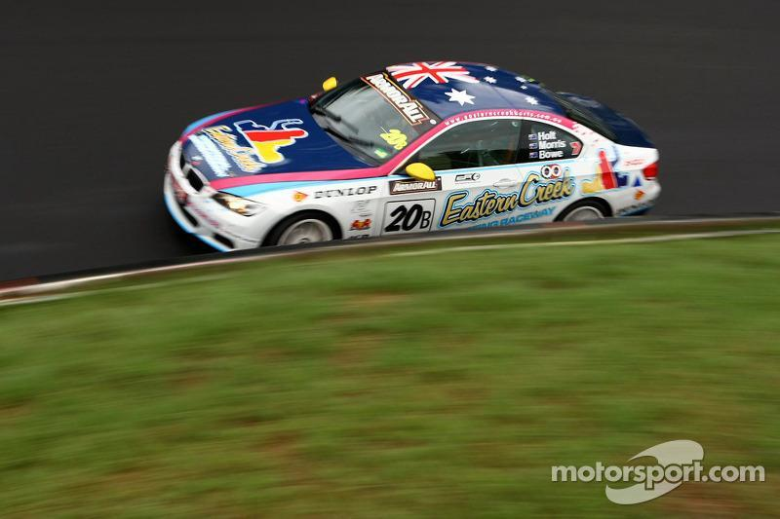

The Eastern Creek Karts team - led by Sydney entrepreneur, Garry Holt - is the most successful motorsport outfit in ‘off-the-showroom-floor’ Production Car racing over the last 10 years in Australia.

From 2006 through to 2015, Garry and his team have won four Australian Championships, two outright Bathurst 12 Hour races, three class wins at the Bathurst 12 Hour and in fact, haven’t finished any lower than second in Australian Production Car style Championships.

The dedicated crew have developed systems that have been unrivalled in Production Car racing in Australia and now are taking on a new challenge with the Toyota 86 Racing Series.

EASTERN CREEK KARTS TEAM ACHIEVEMENTS

2 x Bathurst 12 Hour Outright Winner (2007, 2010)
3 x Bathurst 12 Hour Class Winner
2 x Australian Production Car Champion (2007, 2010)
1 x Australian GTP Championship (forerunner to Manufacturer’s Championship) (2006)
1 x Australian Manufacturer’s Champion (2013)
3 x Runner Up Australian Production Car Championship (2008, 2009, 2011)
1 x Runner Up Australian Manufacturers Championship (2014)
3 x Bathurst 1000 V8 Supercars starts
3 x V8 Supercar Development Series seasons

HOW IT WORKS
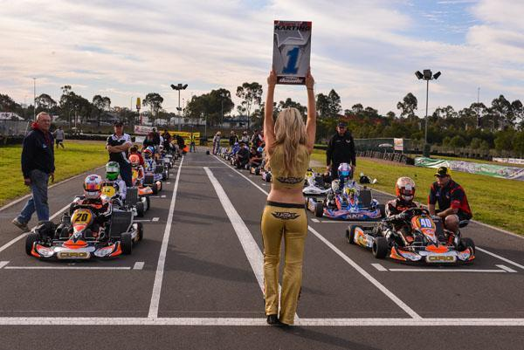

In a rare value-for-value proposition, over and above signage on the Eastern Creek Karts-run Toyota 86 Racing Series car - corporate entertainment and other marketing opportunities at the Eastern Creek Karts corporate karting venue are included in each package.

Toyota Australia is committed to the Toyota 86 Racing Series for a period of 3 years starting in May 2016.

THE PACKAGE:
Each package includes the following:
- Your company’s signage at Eastern Creek Karts for the duration of agreement
- Signage at Cafe Re-Fuel and preferred supplier status (in the case of FMCG/F&B brands)
- Promotional Grid Girls
- Corporate opportunities within pit garage at events
- Activation and Corporate Hospitality opportunities at events (at cost)
- 3 x Electronic Direct Mailers per year to the Eastern Creek Karts database (100,000+ and growing) throughout the year to promote your products/sales

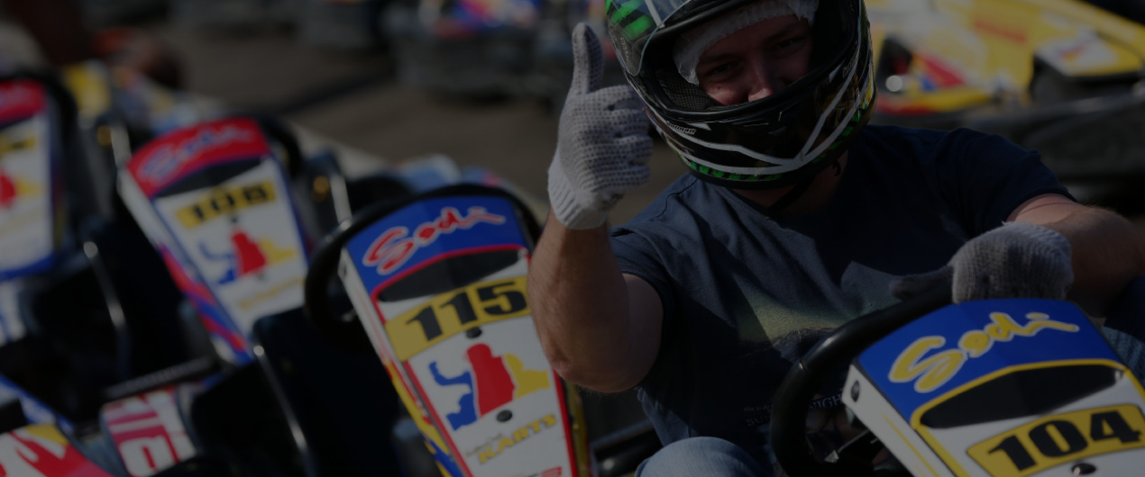

ONE YEAR - $50,000
- Major signage on both sides of the Toyota 86 race vehicle for 2016
- Car to be referred to as ‘Your Brand’ Toyota 86 in all materials by team, Series & media
- Major signage on dash for in-car camera
- 2 x Corporate/Promotional Events at Eastern Creek Karts (max value $25,000)

TWO YEARS: $75,000
- Major signage on both sides of the Toyota 86 race vehicle for 2016 and 2017
- Car to be referred to as ‘Your Brand’ Toyota 86 in all materials by team, Series & media
- Major signage on dash for in-car camera
- 3 x Corporate/Promotional Events at Eastern Creek Karts (max value $30,000)

THREE YEARS: $100,000
- Major signage on both sides of the Toyota 86 race vehicle for the full three year minimum - 2016, 2017 and 2018
- Car will become iconically known as the ‘Your Brand’ Toyota 86 among fans, team, Series & media
- Major signage on dash for in-car camera
- 4 x Corporate/Promotional events at Eastern Creek Karts (max value $50,000)

ADDITIONAL OPPORTUNITIES:

Over and above the outlined packages, the Eastern Creek Karts team is open to additional opportunities that you can utilise on a business-to-business basis to involve suppliers or other partners - this may include, but isn’t limited to:

- Consumables (for use at karting facility and where applicable on racecar and/or transport vehicle)
- Product - spare parts supply for racecar (in line with Toyota 86 Racing Series Technical Regulations)
- Team Uniforms
- Food supply for race team
- Accommodation allocation

Exposure through Eastern Creek Karts is to be considered as value adds for your brand to each package and all corporate options can be tailored specifically to your requirements.

Funding from your suppliers to offer your brand the major signage is also an option.

Thank-you for the opportunity to present this proposal and we look forward to going racing with you in 2016 and beyond!

For further information on this exciting package, contact:

Garry Holt
0413 879 879
garry@easterncreekkarts.com.au

Bill O’Gorman
0420 817 407
bill@eck.com.au

